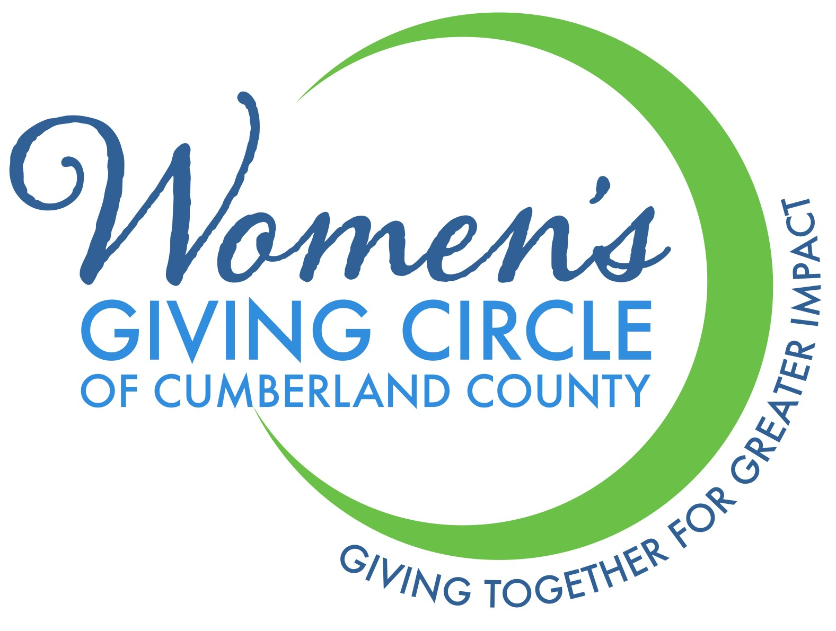
Become a ‘Friend’ of the Women’s Giving Circle of Cumberland County

Contribute to the Women’s Giving Circle of Cumberland County Endowment.
Contact Information:
Name:
Mailing Address:
City/State/Zip:
Email:

Contribution:
I wish to support the Women’s Giving Circle of Cumberland County with a ‘Friend’ donation of:
__ $50 __$500
__$100 __$1000
__$250 __Other amount: $__________
Please make checks payable to Cumberland Community Foundation. Women’s Giving Circle of Cumberland County should appear in the memo line.

I wish to transfer stock/securities. My broker ___________________ Tel:__________________

Will transfer_________ shares of __________________________________________to:
Cumberland Community Foundation, Inc. Please contact Mary Anne Brooks for assistance with marketable securities at 910-483-4449.
Signature: _________________________________________ Date: ______________________

Please return this form to: Susan Barnes/Cumberland Community Foundation/P.O. Box 2345/Fayetteville, NC 28302-2345/910-483-4449

